
Year 9 Mathematics
Mini-Test – Trigonometry & Scientific Notation
Resource Section (Calculators and notes allowed)

Time: 40 mins Name: _______________________________ / 49 marks

Multi-choice Section 5 marks

- Which is the correct scientific notation representation of the following number: 47 000
- 47.00 x 10⁴
- 4.7 x 10⁻⁴
- 4.7 x 10⁴
- 0.47 x 10⁴

- Which is the correct representation of the following number: 9.324 x 10⁻⁵
- 9,324,000
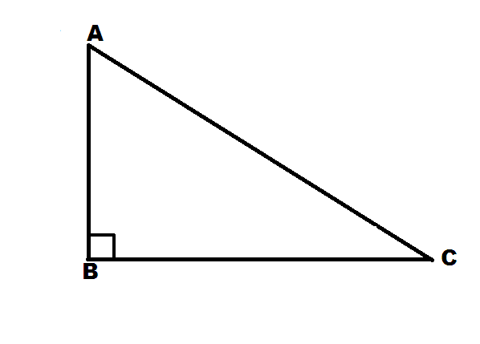
- 932,400
- 0.000009324
- 0.00009324
Hypotenuse
Opposite
Ѳ

- What is the correct name for the missing side (x) in the picture:
  - Hypotenuse
  - Adjacent
x
  - Opposite
  - Pythagoras


- Which one is the correct trigonometry ratio for the following triangle:
Ѳ
- SinѲ = $\frac{Opposite}{Hypoenuse}$
Adjacentnt

- TanѲ = $\frac{Opposite}{Adjacent}$
Opposite
- CosѲ = $\frac{Adjacent}{Hypotenuse}$

- Which one is the correct answer: Cos45° = $\frac{13}{x}$
- x = 18.38
- x = 24.75
- x = 17.09
- x = 18.28

Question 6 12 marks
Complete the following table:

Scientific Notation | Numeral
3 x 10¹
3 x 10²
 | 3000
3 x 10⁴

- Write the following as a numeral.

2 x 10⁵ = ____________________________ | 1.9 x 10⁻¹= ______________________________
8.3 x 10⁷ = __________________________ | 4 x 10⁻⁵ = ________________________________
- Write the following numbers in scientific notation.

60 = ______________________ | 420,000,000 = ______________________
0.0000064 = ___________________ | 0.00005008 = _____________________

Question 7 5 marks

Simplify the following. Write each answer in scientific notation. Show all your working out.

a. $\frac{6.6 × {10}^{4}}{2.99 × {10}^{6}}$ b. (5.91 x 10³)(9 x 10⁴)

c. Find the difference between 4.2 x 10⁷ and 4.2 x 10⁵.

Question 8 4 marks

Find the value of each of the trigonometric ratio, rounding to 3 decimal places

- Sin62° = _____________
- Tan79° = ____________

Find the value of each angle to the nearest degree.

- SinѲ= 0.7547 Ѳ= ____________
- CosѲ= 0.5736 Ѳ=_____________

Question 9 9 marks

Solve the following by:
- Labelling the sides (O, A, H)
- Choose the correct trigonometry ratio
- Use the ratio to find the length of the side marked with a letter (to 3 d.p).
- Show all your working out.

m  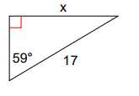 | 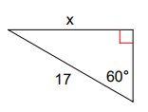  k
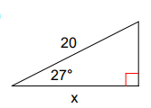
y

Question 10 6 marks

Solve the following by:
- Label the sides (O, A, H)
- Choose the correct trigonometry ratio
- Use the ratio to find the value of angle marked with a symbol .
- Show all your working out.

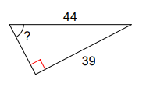  Ѳ | 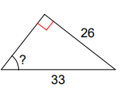  α
Extension Question 8 marks

- A 9 m ladder rests against the side of a wall. The bottom of the ladder is 1.5 m from the base of the wall. Label the diagram to help you. Show all working out.
  - Determine the measure of the angle between the ladder and the ground.

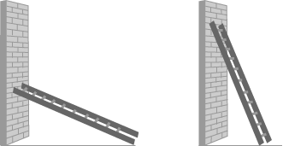

  - How far up the wall does the ladder reach?

- Craig wants to measure the height of a tree. He walks exactly 80 m away from the tree. The angle from the ground to the top of the tree is 33°. How tall is the tree?
- Show all your working out



End of Test

